# **1 Introduction**

RF coils are needed to transmit and receive radio-frequency waves used in MRI scanners. They are one of the most important components that affect image quality. First step taken was to build an RF coil for MRI field strength of 1.5Tesla which needs to be resonant at the target Larmor frequency (63.87MHz). RF coils are usually made up of conducting wires, inductor and capacitors.

# **1.2 Simulation**

**1.2.1. Biot Savart**

The magnetic field generated by a finite current element can be calculated by using the Biot Savart law. For any shape of coil like wire segment, loop, arc etc. divided into a series of finite current element and by using the Biot Savart law, the generated distribution of magnetic field by the coil at any point can be calculated. Equation (1) shows the Biot Savart law.

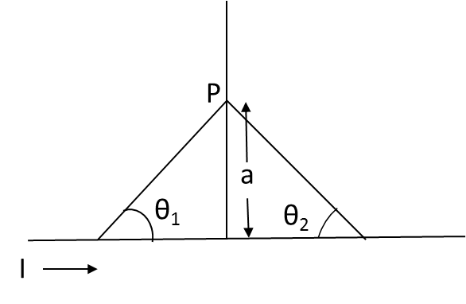

*Figure 1.1: Parameter related to Biot Savart Law*

From Figure 1.1, Magnetic field due to a finite straight wire element. A straight wire carrying a current ‘I’ is placed along x-axis. The magnetic field at point ‘P’ is evaluated by assuming that the lead to the ends of the wire make canceling, contribution to the net magnetic field at the point ‘P’ is shown in the below equation.

Similarly, magnetic field generated by different geometrical coil shapes can be calculated by using above same equation (1). Visualization of distribution of magnetic field around the different geometrical coils like wire segment, loop and arc are shown and discussed in the result section.

The geometry of the magnetic field is set up to correctly model forces between currents that allow for any relative orientation. The magnetic field intensity, H, circulates around its source, *I*, in a direction most easily determined by the right-hand rule.

A magnetic field can be generated by an electrical current flow (I) through a conductor. Per unit current the strength and orientation of this field in the object that is measured can be approximated using the law of Biot-Savart.

The below equation is to calculate magnetic field across X-axis

The below equation is to calculate magnetic field across Y-axis

Where

**μ0** is the permeability constant

I is the current in ampere

p is the point in a free space.

a is the distance between centre point and point p

The below equation is to calculate total (net) magnetic field in 3D

We have implemented the above three equations for calculating magnetic field around loop coil.

Simulation is performed on a coil placed with different position along Z-axis with different current and viewed the magnetic field using “**quiver**‟ command.

|  |  |  |
| --- | --- | --- |
| Z=-4 for 5 amp current | Z=-2 for 10 amp current | Z=-0 for 15 amp current |
|  |  |  |
| Z=+2 for 20 amp current | **Z=+4 for 25 amp current** | **All five coils** |
|  |  |  |

*Figure 1.2: Field variation of coils at different position along Z axis for different current amplitude*

Surface coil integration only for proton nucleus coil by entering the values of outer and inner diameter of coil, the magnetic field distribution can visualize in ‘Display’ panel Surface coil integration for different geometries like wire segment, loop and arc are done and shown in figure 1.3

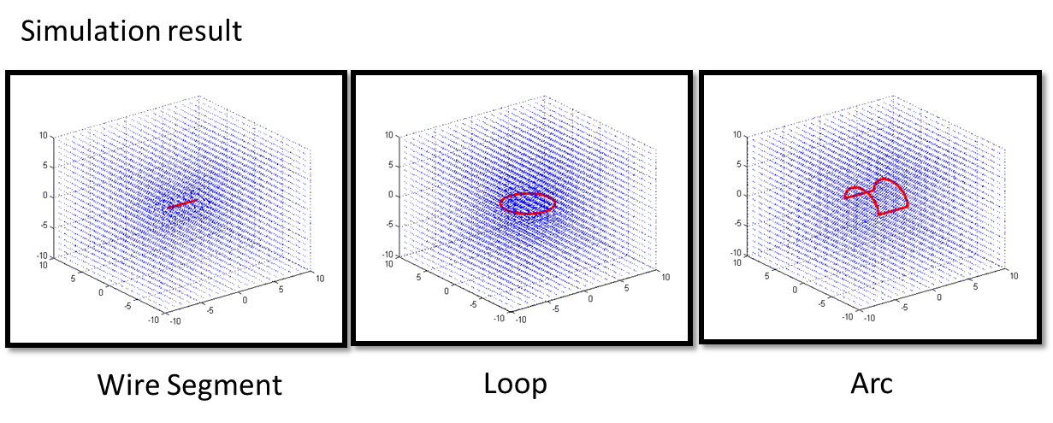

*Figure 1.3: Distribution of magnetic field around different geometrical shaped coils*

Matlab simulation results for different geometrical shaped coils is as shown in the figure 1.3, interpretation of distribution of magnetic field around the coil are more nearer to the coil rather than far field and also magnetic field depends on coil size and position of the coil. Based on coil position different magnetic field distribution can be seen by entering the coil position value in Graphical User Interface (GUI) is shown in the figure 1.4

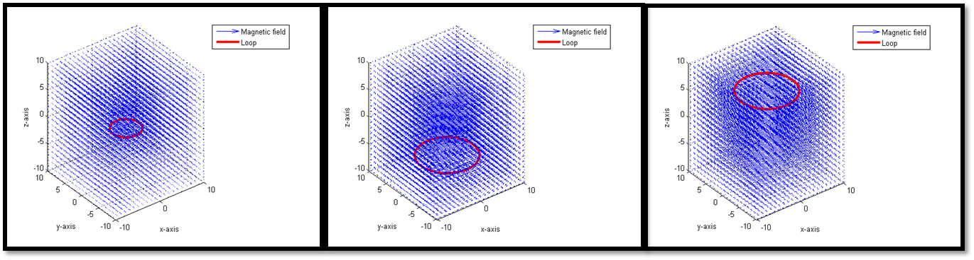

*Figure 1.4: Magnetic field distribution at different coil position*

Simulation shows a sensitivity of the coil and the magnetic field. Depth of penetration is equal to the radius of a coil. The simulation provide an assistance to Radio Frequency (RF) coil designer.

**1.2.2. Graphical User Interface**

GUI window contains three sub windows 1. Choose coil, 2. Types and 3. Display. After getting every output go to File and Refresh Hardware_UI for clearing all figures and display window.

Step 1: Select Surface coil either ‘Wire’ or ‘Loop’ or ‘Arc’.

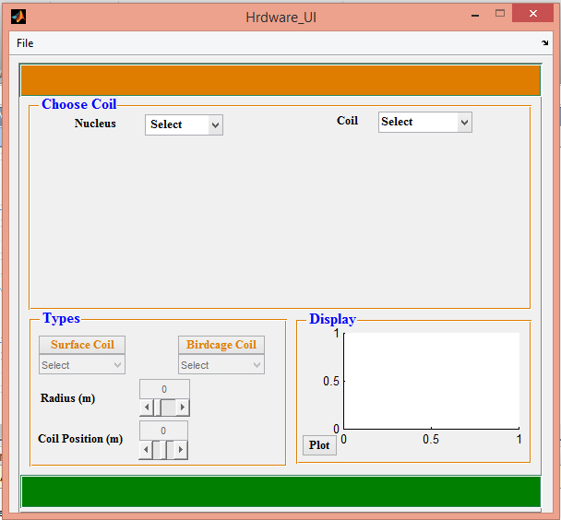 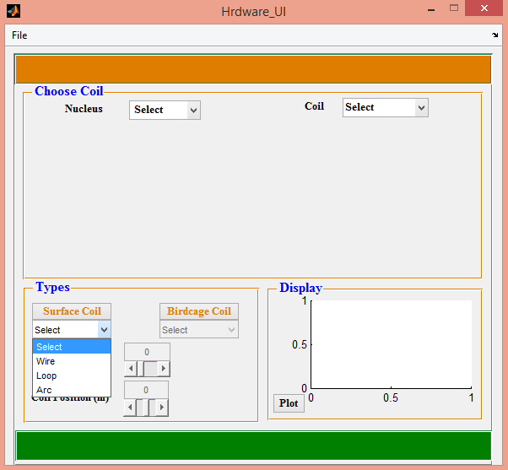

*Figure 1.5: GUI window*

Step 2:

1. Select wire and then plot.

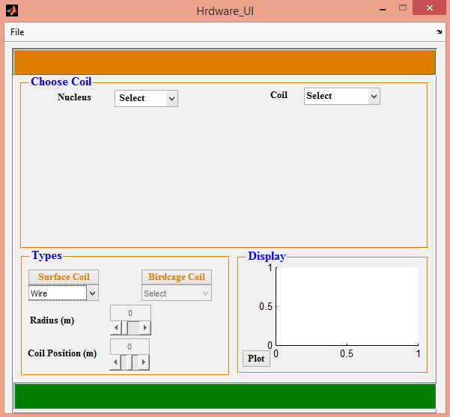 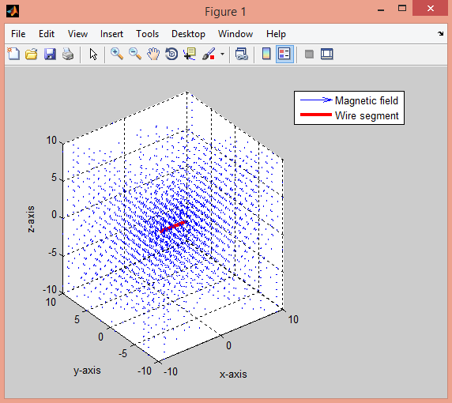

*Figure 1.6: GUI window and the distribution of magnetic field around the wire segment*

1. If you have selected ‘Loop’ following parameters like ‘Radius’ and ‘Coil Position’ will enable and assign radius and coil position.

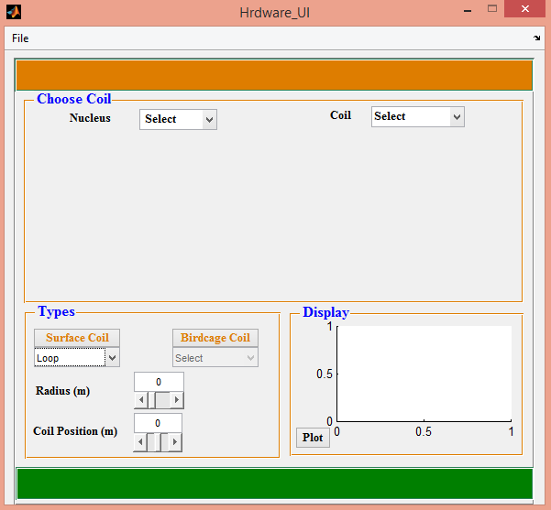 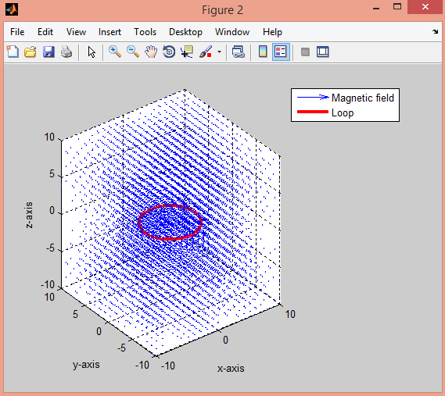

*Figure 1.7: GUI window and field distribution around the loop segment*

Magnetic field distribution around the loop segment is shown above and we can also visualize different field distribution for different radius and coil position.

1. Select Arc and then plot.

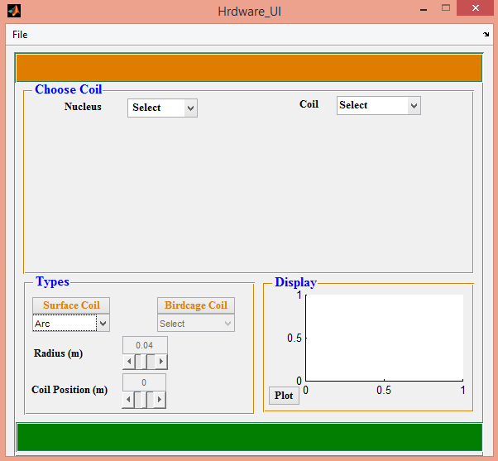 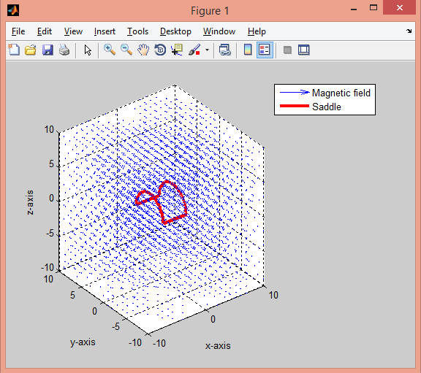

*Figure 1.8: GUI window and field distribution around the Arc*

The below result shows the distribution of magnetic field for a loop using imagesc command.

Results are showed using “**imagesc**” command in the **Matlab** software.

 

*Figure 1.9.1: Inner dia=0.1m and outer dia=0.5m**Figure 1.9.2. Inner dia=0.09m and outer dia=0.27m*

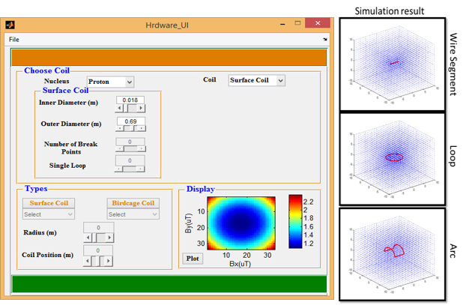

*Figure 1.10: GUI window with selected coil parameter, coil sensitivity profile and field distribution for different coil shape*

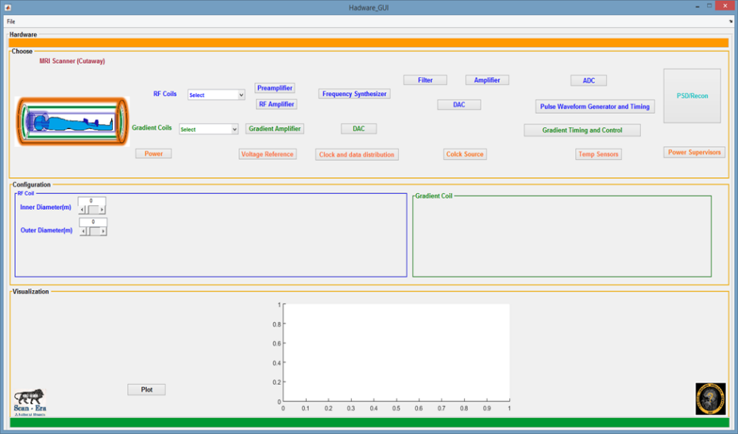

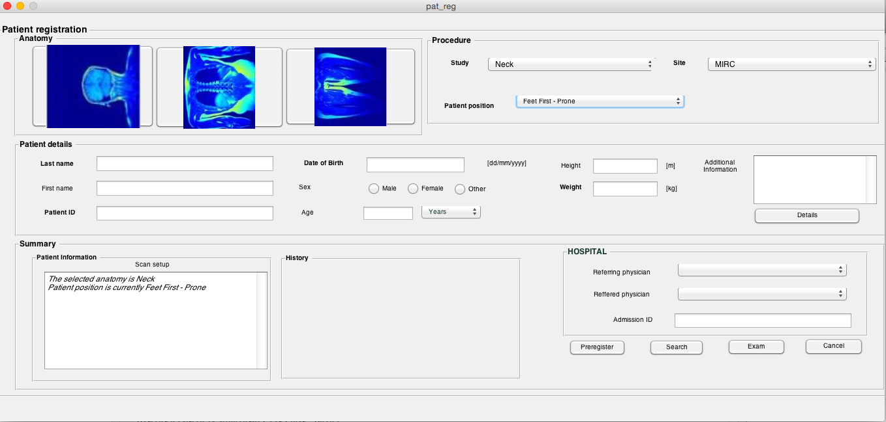

*Figure 1.11: Updated GUI*

**1.2.3 16 channel head coil for 1.5T**

**Simulation:**

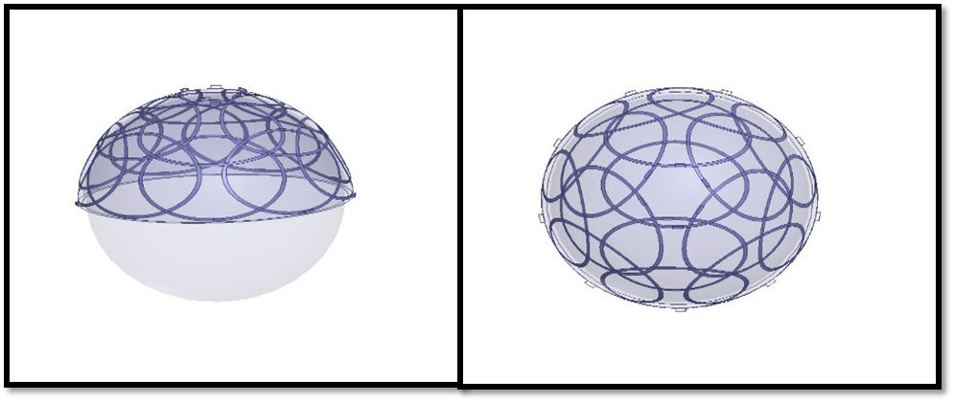

*Figure 1.12: Side and Top view of 16 channel coil arrangement*

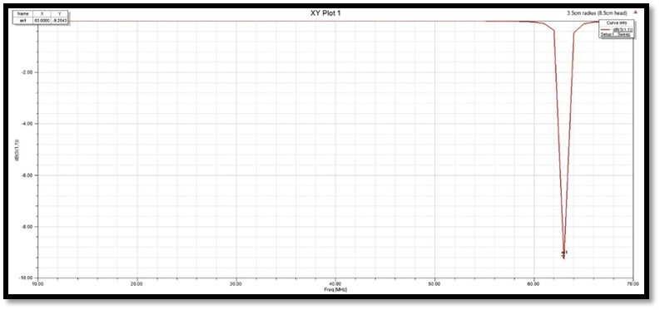

*Figure 1.13: Single coil element resonating at 64MHz with -9.2dB (S11 measurement)*

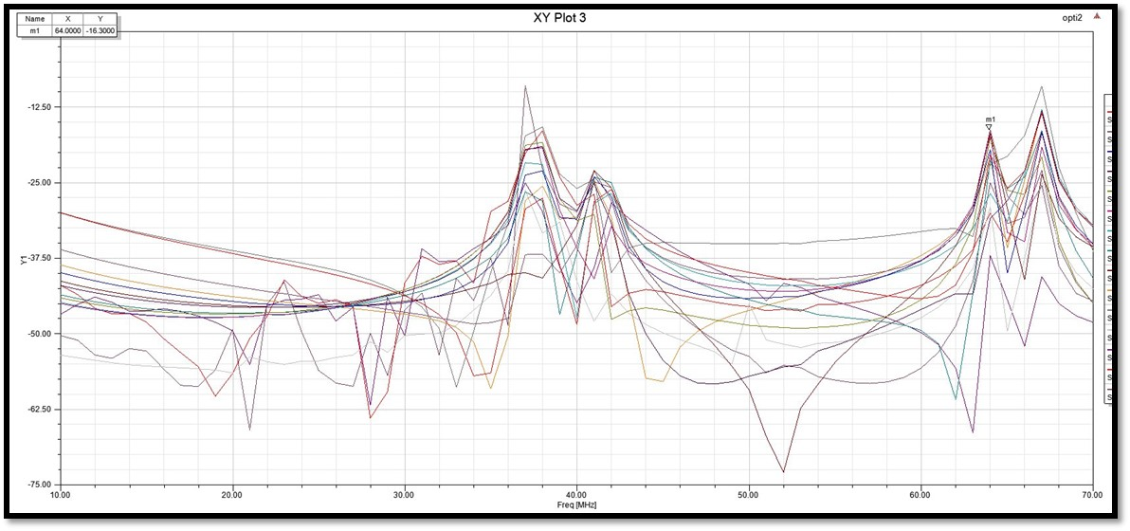

*Figure 1.14: Mutual coupling between the coils (S21 measurement)*

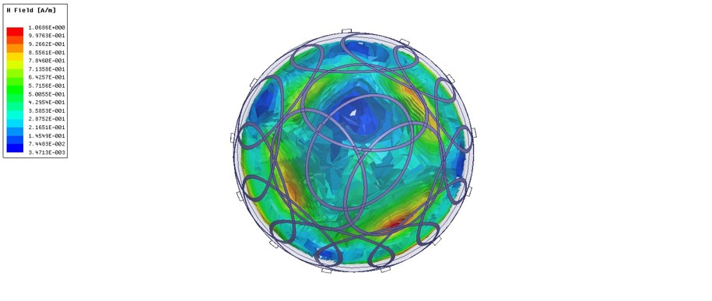

*Figure 1.15: H field distribution*

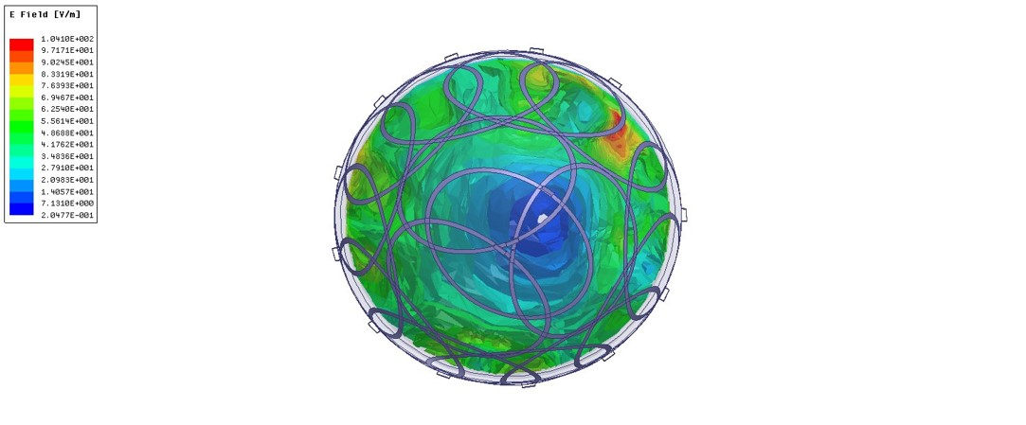

*Figure 1.16: E field distribution*

# **1.3 Implementation**

**Material and Methods:**

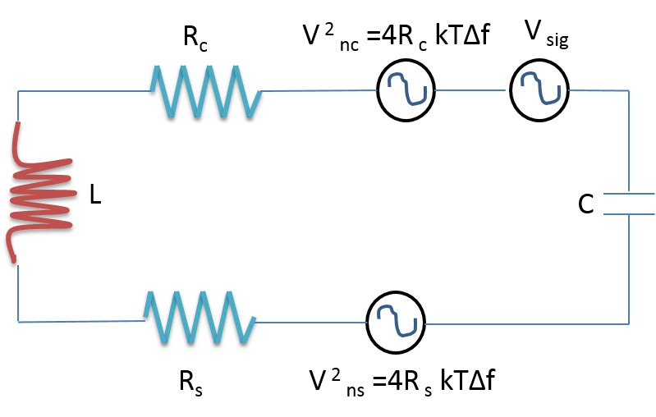

*Figure 1.17: circuit model of a single loop with loaded sample*

Figure 1.17 shows the circuit model of a single loop coil . The SNR of the loop detector measured as a power ratio is given as

SNR power = V 2sig /V 2n

Where V 2sig is the signal power and V 2n is the noise power. Vn includes the noise contribution from sample and from the loop

V2n= V 2nc + V 2ns = 4(Rc + Rs )kTΔf

Where, Rc and Rs are loop and sample volume resistive losses respectively, k, is Boltzmann’s constant; T is the sample and coil temperature in K and Δf is the receiver bandwidth in Hz.

**B1 field of a circular loop**:

Magnetic field produced at any point in free space can be calculated by using Biot Savart law and it is given by

*Where,* M sample magnetization, V volume of the sample, A is the area of circular loop and βrec geometry of the circular loop coil

Where, a is the radius of the coil and d is the distance between coil and sample

**Inductance of a Loop coil:**

The inductance of the wire loop are measured by using LCR meter and also determined from formula.

The resistance is calculated using the following equation

Where, skin depth (δ)

Where, ρ is the resistivity of the copper wire, D is the diameter of the circular loop and d is the diameter of the wirer

**Tuning and Matching:**

The coil and its equivalent circuit as shown in the figure 1.18. Inductance L, of the coil and Equivalent resistance of the (Req) coil which includes the ESR of tuning and matching capacitance value. The geometry of the coil helps to estimate the inductance of the coil. Capacitance value calculated at the right resonance peak (ω). Adjust the tuning (CT) and matching (CM) capacitance until we look the resonance response of the coil for known inductance value.

Match the coil impedance to 50 ohm at resonance frequency (ω). This can be achieved by matching network as shown in the figure 1.19.

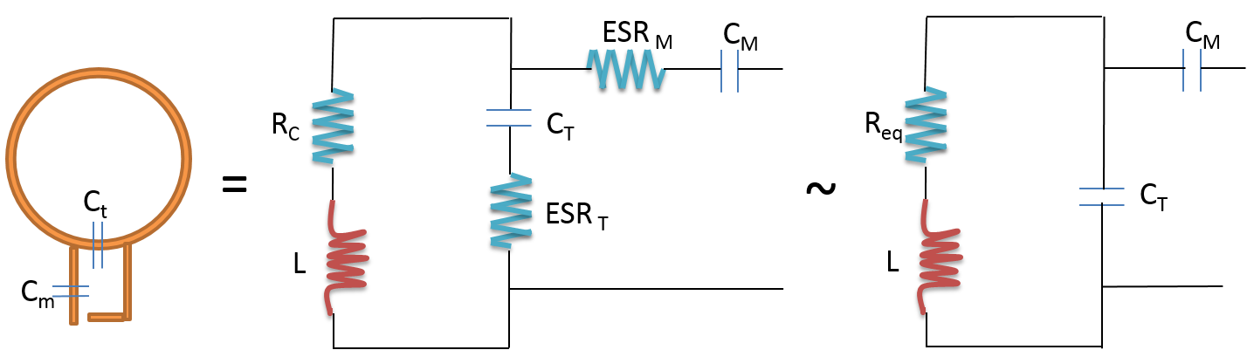

*Figure 1.18: parallel tuned coil with equivalent circuit*

**Impedance matching with low input impedance preamplifier:**

Matching network would transform the resistance of the tuned coil to 50 ohm. For example, inductance L, capacitance C1 and C2 are chosen to transform resistance of the coil to 50 ohm impedance of the preamplifier. The 50 ohm impedance is easily to achieve with parallel circuit. L and C1 together forms a parallel resonance circuit with input of the preamplifier.

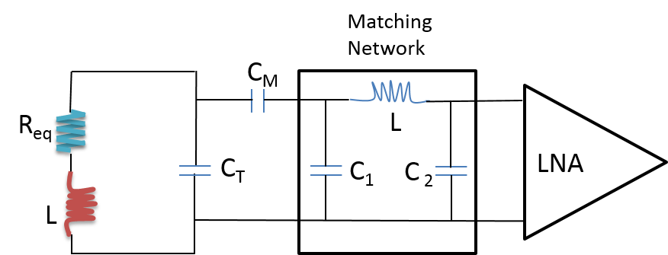

*Figure 1.19: Circuit diagram of MR detector including matching network and pre amplifier*

**Coil characterization:**

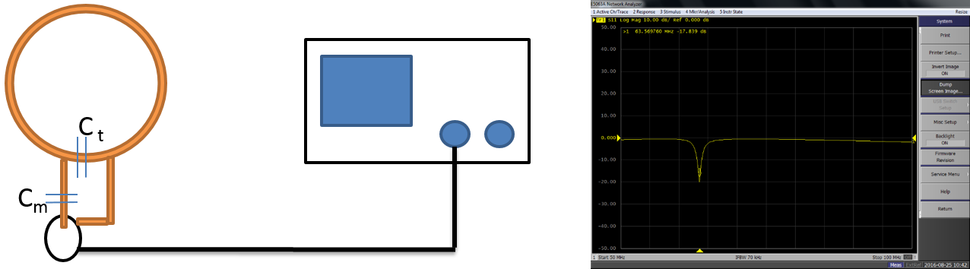

*Figure 1.20: S11 frequency response of the coil tuning and matching*

Once the coil is tuned and matched to desired frequency such that the resistance is 50 ohm and reactance is 0. Coil return loss S11 as depicted in a figure 1.20.

**3.3.1 Bench measurement**

The goal of this project is to design 16 element head array coil and prototyping for 1.5T. Coils are circular shaped and arranged on a helmet former. Coils were overlapped to cancel out the mutual inductance. Circularly shaped and arranged coils are distributed over helmet former with 26.5cm and 23cm from the anterior to posterior and left to right direction respectively. Each coil dimension was 9cm and tuned and matched for resonance frequency 63.8MHz, 1.5T. Coil constructed using 20 AWG and schematic diagram as shown in the figure 1.22

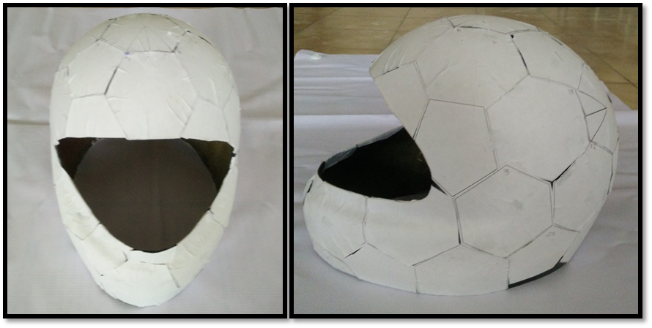

*Figure 1.21: Head former*

The S11 parameter of each coil are measured using network analyzer.

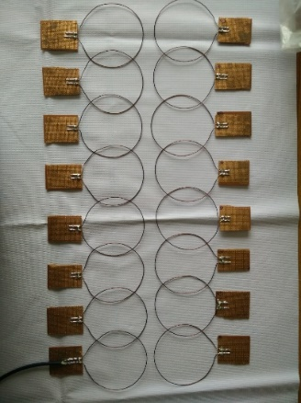 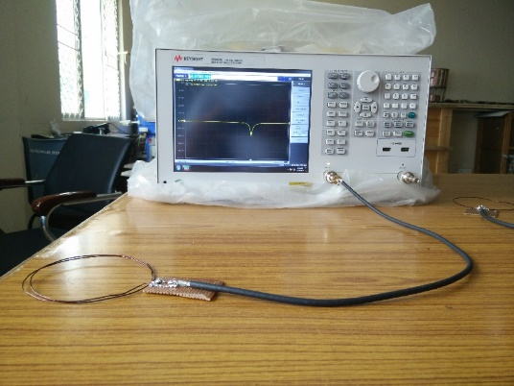

*Figure 1.22.1: 16 channel coil working at 63.8MHz of -18dB Figure 1.22.2: Coil characterization using network analyzer*

# 1.4 References

1. R. Wolfson and J. Pasachoff,, Physics with Modern Physics (3rd Edition, Addison-Wesley Longman, Don Mills ON, 1999
2. Vaughan, J. Thomas, and John R. Griffiths, eds. RF coils for MRI. John Wiley & Sons, 2012
3. Roemer, Peter B., et al. "The NMR phased array." *Magnetic resonance in medicine* 16.2 (1990): 192-225
4. Mak, Chi-Lun, Wan-Ming Lau, and Corbett Ray Rowell. "RF coil arrays for MRI applications." *Antennas and Propagation (APSURSI), 2011 IEEE International Symposium on*. IEEE, 2011.